Sriram R – PES1UG20CS435

Week #1

**Task 1: Linux Interface Configuration (ifconfig / IP command) Step 1:** To display status of all active network interfaces.

# ifconfig (or) ip addr show

# 

Analyze and fill the following table:

# ip address table:

|  |  |  |
| --- | --- | --- |
| **Interface name** | **IP address (IPv4 / IPv6)** | **MAC address** |
| lo | 125.0.0.1 | <loopback> |
| enp0s3 | 10.0.2.15 | 08:00:27:a3:3c:e3 |

**Step 2:** To assign an IP address to an interface, use the following command.

# sudo ifconfig interface_name 10.0.your_section.your_sno netmask 255.255.255.0 (or)

**sudo ip addr add 10.0.your_section.your_sno /24 dev interface_name**

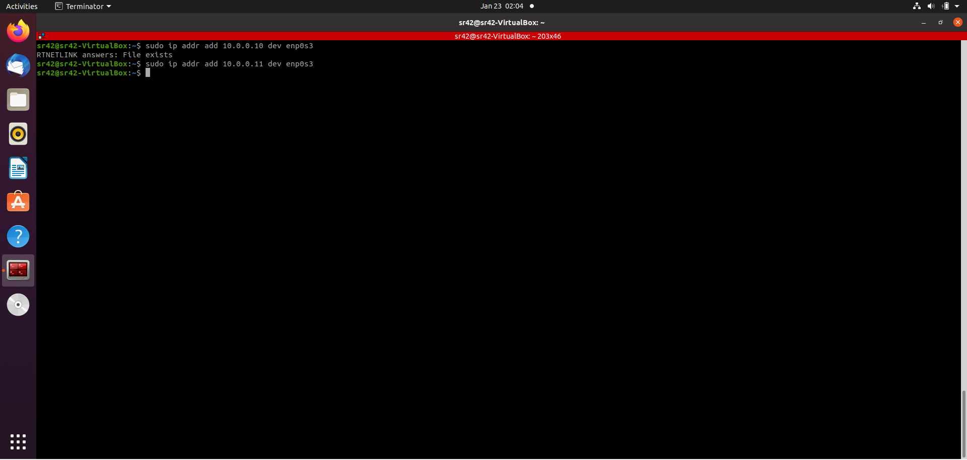

**Step 3:** To activate / deactivate a network interface, type.

# sudo ifconfig interface_name down sudo ifconfig interface_name up

# 

**Step 4:** To show the current neighbor table in kernel, type

# ip neigh

# 

**Task 2: Ping PDU (Packet Data Units or Packets) Capture Step 1:** Assign an IP address to the system (Host).

Note: IP address of your system should be 10.0.your_section.your_sno.

**Step 2:** Launch Wireshark and select ‘any’ interface

**Step 3:** In terminal, type **ping 10.0.your_section.your_sno**

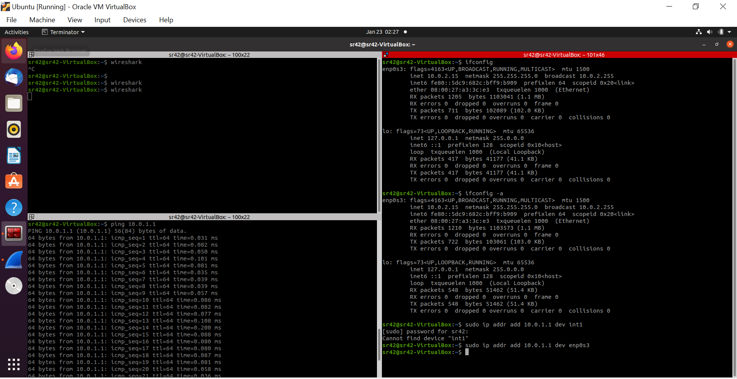

# Observations to be made

**Step 4:** Analyze the following in Terminal

* TTL
* Protocol used by ping
* Time

**Step 5:** Analyze the following in Wireshark

On Packet List Pane, select the first echo packet on the list. On Packet Details Pane, click on each of the four “+” to expand the information. Analyze the frames with the first echo request and echo reply and complete the table below.

|  |  |  |
| --- | --- | --- |
| **Details** | **First Echo Request** | **First Echo Reply** |
| Frame Number | 1 | 2 |
| Source IP address | 10.0.1.1 | 10.0.1.1 |
| Destination IP address | 10.0.1.1 | 10.0.1.1 |
| ICMP Type Value | 8 | 0 |
| ICMP Code Value | 0 | 0 |
| Source Ethernet Address | 00:00:00:00:00:00 | 00:00:00:00:00:00 |
| Destination Ethernet Address | 00:00:00:00:00:00 | 00:00:00:00:00:00 |
| Internet Protocol Version | 4 | 4 |
| Time To Live (TTL) Value | 64 | 64 |

# Task 3: HTTP PDU Capture Using Wireshark’s Filter feature

**Step 1:** Launch Wireshark and select ‘any’ interface. On the Filter toolbar, type-in ‘http’ and press enter

**Step 2:** Open Firefox browser, and browse [info.cern.ch](http://www.flipkart.com/)

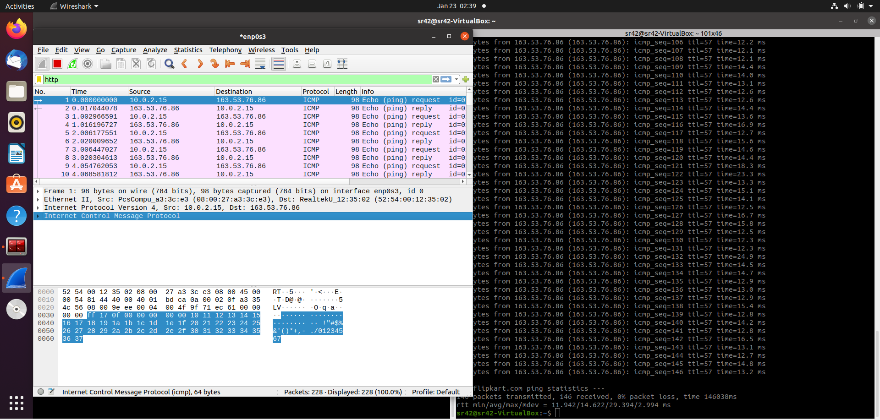

# Observations to be made

**Step 3:** Analyze the first (interaction of host to the web server) and second frame (response of server to the client). By analyzing the filtered frames, complete the table below:

|  |  |  |
| --- | --- | --- |
| **Details** | **First Echo Request** | **First Echo Reply** |
| Frame Number | 1 | 2 |
| Source Port | 33799 | 80 |
| Destination Port | 80 | 33799 |
| Source IP address | 10.0.2.15 | 163.53.76.86 |
| Destination IP address | 163.53.76.86 | 10.0.2.15 |
| Source Ethernet Address | 08:00:27:a3:3c:e3 | 08:00:27:a3:3c:e3 |
| Destination Ethernet Address | 52:54:00:12:35:02 | 52:54:00:12:35:02 |

**Step 4:** Analyze the HTTP request and response and complete the table below.

|  |  |  |  |
| --- | --- | --- | --- |
| **HTTP Request** |  | **HTTP Response** |  |
| Get | GET / HTTP/1.1\r\n | Server | HTTP/1.1 200 OK\r\n |

|  |  |  |  |
| --- | --- | --- | --- |
| Host | info.cern.ch\r\n | Content-Type | text/html |
| User-Agent | Mozilla/5.0 (X11; Ubuntu; Linux x86_64; rv:96.0) Gecko/20100101 Firefox/96.0 | Date | Sat, 22 Jan 2022 21:32:17 GMT |
| Accept-Language | en-US,en;q=0.5 | Location | n/a |
| Accept-Encoding | gzip, deflate | Content-Length | 646 |
| Connection | keep-alive | Connection | close |

# Using Wireshark’s Follow TCP Stream

**Step 1:** Make sure the filter is blank. Right-click any packet inside the Packet List Pane, then select ‘Follow TCP Stream’. For demo purpose, a packet containing the HTTP GET request “GET / HTTP / 1.1” can be selected.

Step 2: Upon following a TCP stream, screenshot the whole window.

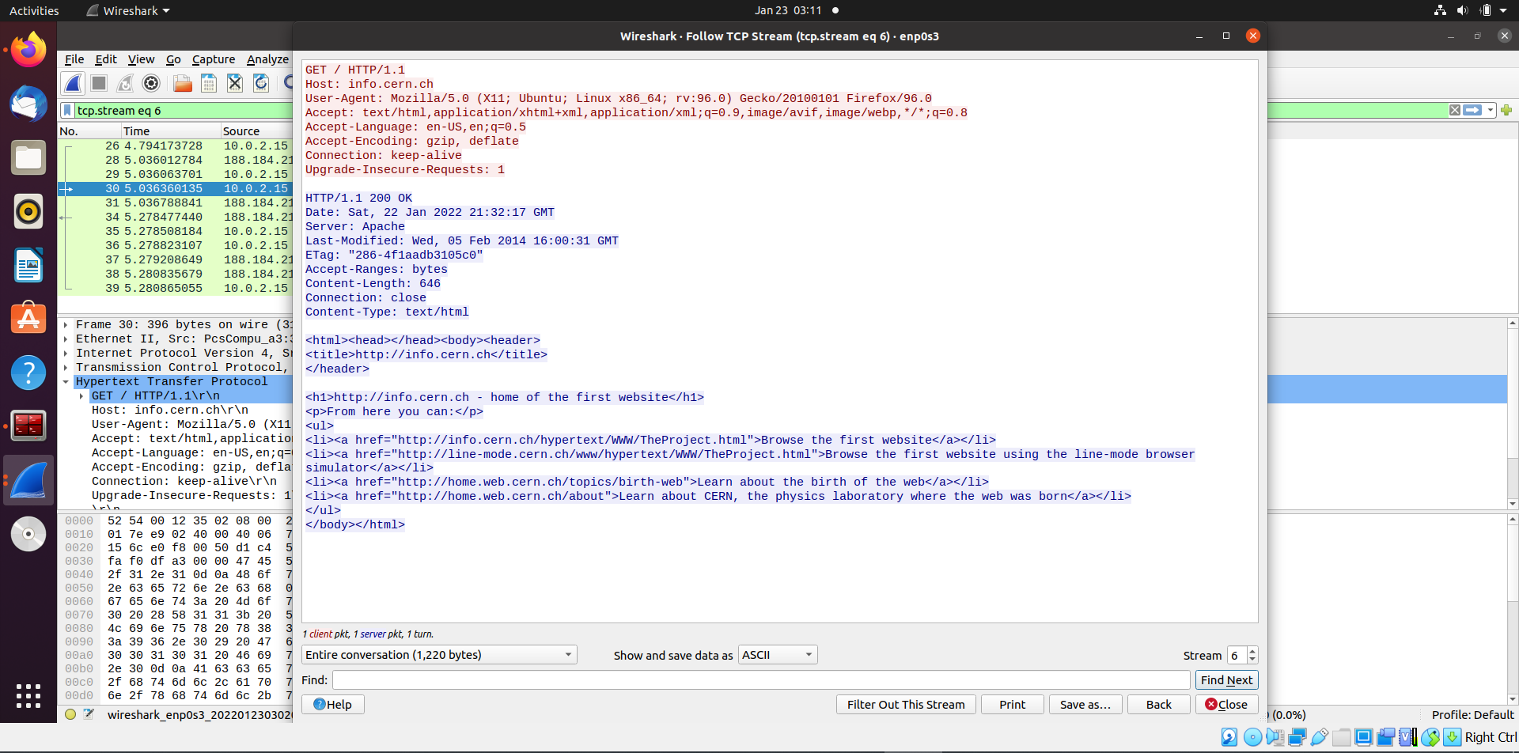

# Task 4: Capturing packets with tcpdump

**Step 1:** Use the command **tcpdump -D** to see which interfaces are available for capture.

# sudo tcpdump –D

# 

**Step 2:** Capture all packets in any interface by running this command:

# sudo tcpdump -i any

# 

Note: Perform some pinging operation while giving above command. Also type [www.google.com](http://www.google.com/) in browser.

# Observation

**Step 3:** Understand the output format.

**Step 4:** To filter packets based on protocol, specifying the protocol in the command line. For example, capture ICMP packets only by using this command:

# sudo tcpdump -i any -c5 icmp

# 

**Step 5:** Check the packet content. For example, inspect the HTTP content of a web request like this:

# sudo tcpdump -i any -c10 -nn -A port 80

# 

**Task 5: Perform Traceroute checks**

**Step 1:** Run the traceroute using the following command.

# sudo traceroute [www.google.com](http://www.google.com/)

# 

**Step 2:** Analyze destination address of google.com and no. of hops

**Step 3:** To speed up the process, you can disable the mapping of IP addresses with hostnames by using the *-n* option

# sudo traceroute -n [info.cern.ch](http://www.google.com/)

# 

**Step 4:** The -I option is necessary so that the traceroute uses [ICMP](https://en.wikipedia.org/wiki/Internet_Control_Message_Protocol).

# sudo traceroute -I [www.google.com](http://www.google.com/)

# 

**Step 5:** By default, traceroute uses icmp (ping) packets. If you’d rather test a TCP connection to gather data more relevant to web server, you can use the -T flag.

# sudo traceroute -T [www.google.com](http://www.google.com/)

# 

**Task 6: Explore an entire network for information (Nmap)**

**Step 1:** You can scan a host using its host name or IP address, for instance.

# nmap [www.pes.edu](http://www.pes.edu/)

# 

**Step 2:** Alternatively, use an IP address to scan.

# nmap 163.53.78.128

**Step 3:** Scan multiple IP address or subnet (IPv4)

# nmap 192.168.1.1 192.168.1.2 192.168.1.3

**Questions on above observations:**

1. Is your browser running HTTP version 1.0 or 1.1? What version of HTTP is the server? – Ans. : Both the browser & the server run HTTP 1.1
2. When was the HTML file that you are retrieving last modified at the server? – Ans. : Sat, 22 Jan 2022 21:32:17 GMT
3. How to tell ping to exit after a specified number of ECHO_REQUEST packets? – Ans.: ping -c <insert number of packets here>
4. How will you identify remote host apps and OS? – Ans.: nmap –O –v <server IP address>